A

Project Report on

“Online Chatting Room Website ”

At

**GIDC RAJJU SROFF ROFEL INSTITUTE OF MANAGEMENT OF STUDIES (BBA) &**

**ROFEL SHRI G.M BILAKHIA COLLEGE OF APPLIED SCIENCES (BCA), VAPI**

**[ISO 9001:2015,29990-2010 Certified College]**

as a partial fulfilment

for the degree of

Bachelor of Computer Application

(B. C. A.)

2022-2023

**Guided By:** **Submitted By:**

Prof. Binny Patel Shubham Kumar Yadav



GIDC RAJJU SROFF ROFEL INSTITUTE OF MANAGEMENT OF STUDIES (BBA) &

ROFEL SHRI G.M BILAKHIA COLLEGE OF APPLIED SCIENCES (BCA), VAPI



Gidc rajju shroff rofel institute of management studies (bba program ) and ROFEL , Shri G.M Bilakhia College of Applied Sciences (BCA) , VAPI

An ISO Certified 9001-2015 & 29990-2010

An ISO Certified 9001-2015 & 29990-2010

**CERTIFICATE**

This is to certify that the project work entitled “**__Online Chatting Room Website________________**“ is bonefied work done by,

1. **Shubham Kumar Yadav.**

The project work was carried out under our supervision and is certified further that to the best of our knowledge the work reported here in does not form of any other thesis or dissertation or basis of which a degree or any award was conferred on an earlier occasion on any other candidate.

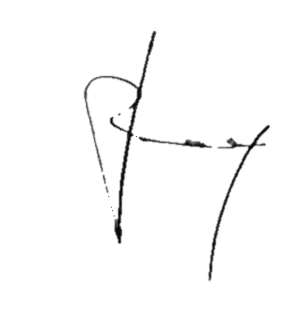 **Guided by Principal**

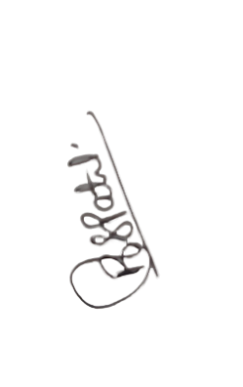

**Prof. Binny Patel**

**Dr.P.H. Ved**

**Table of Contents**

|  |  |  |
| --- | --- | --- |
| SNO. | INDEX | PAGE NO. |
| 1. | Introduction. |  |
| 2. | Objectives. |  |
| 3. | System Flowchart Diagram. |  |
| 4. | Data Flow Diagram (DFD). |  |
| 5. | Entity-Relationship Model Diagram (ER). |  |
| 6. | Screen Shots. |  |

Introduction:-

The primary use of a chat room is to share information via text with a group of other users.

Generally speaking, the ability to converse with multiple people in the same conversation differentiates chat rooms from instant messaging programs, which are more typically designed for one-to-one communication.

The users in a particular chat room are generally connected via a shared internet or other similar connection, and chat rooms exist catering for a wide range of subjects.

To Join The Chating Room:-

To join a chat room, First you'll need to Sign up with a nickname OR you can use your existing username, Email, Password and Image or you can sign up with an alternate username. Second to enter in chating room after sign up Login with your Email and Password to come In chating room.

Security:-

One feature that's been around since the earliest chat rooms is the ability to send a private message to an individual user that can't be seen by the whole group.

Second feature that’s Once you sign up with your username No one can use your name to sign up or login.

OBJECTIVES**:-**

The main objective of the Online Chat Application is to manage the details of Chat Application,Online Chat,Smiles Chat,Users,Chat History. It manages all the information about Chat Application, Chat Profile, Chat History, Chat Application. The purpose of the project is to build an application program to reduce the manual work for managing the Chat Application, Online Chat, Chat Profile, Smiles Chat. It tracks all the details about the Smiles Chat,Users,Chat History.

**SYSTEM FLOWCHART DIAGRAM:-**

System Flowchart is the graphical representation of the flow of data in the system and represents the work process of the system. Various symbols are used in the flowchart to designate specification.

* **Display:**

Indicates data that is displayed for people to read such as data on monitor or projector screen.

* **Process:**

Indicates any processing function.

* **Database:**

Indicates a list of information with a standard structure that allows for searching and sorting.

* **Document:**

Indicates data that can be read by people such as printed output.

**SYSTEM FLOW DIAGRAM:-**

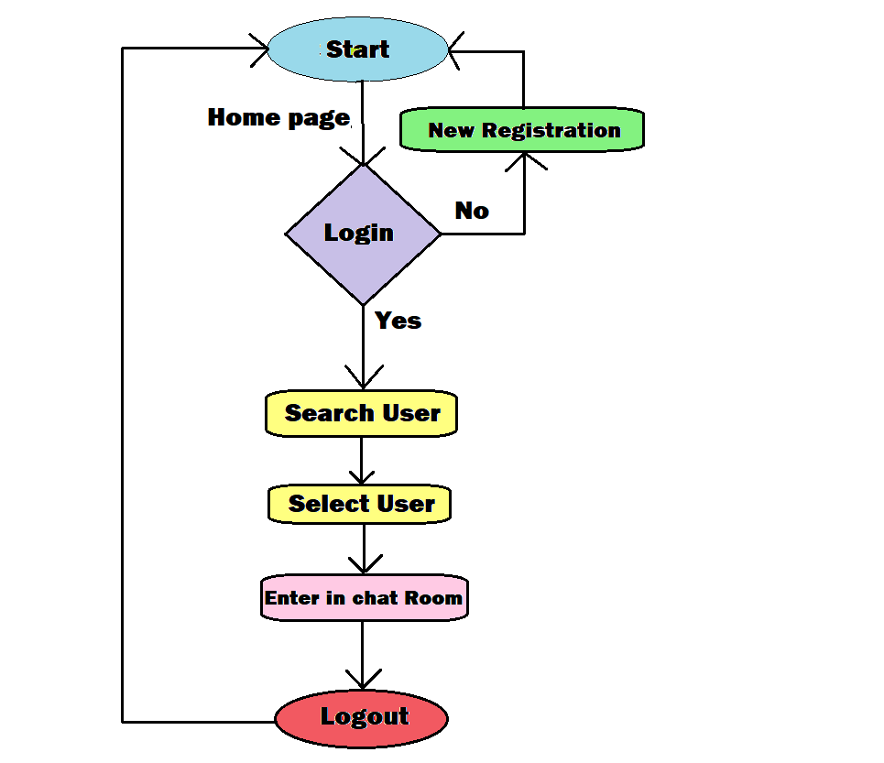

**DFD DIAGRAM:-**

A data flow diagram is graphic representation of a system that shows data flows to from and within the system, processing function that change the data in same manner, and the storage of this data. They are networks of related system function that indicated from where information is revived and to where it is sent. An external entry is the originator or receiver of data or information.

**Zero Level:**

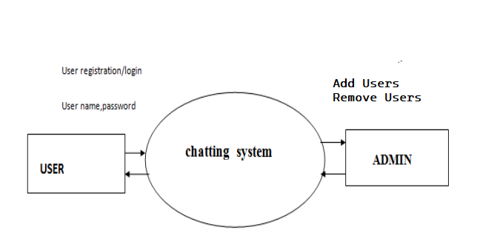

Zero Level DFD.

**First Level:-**

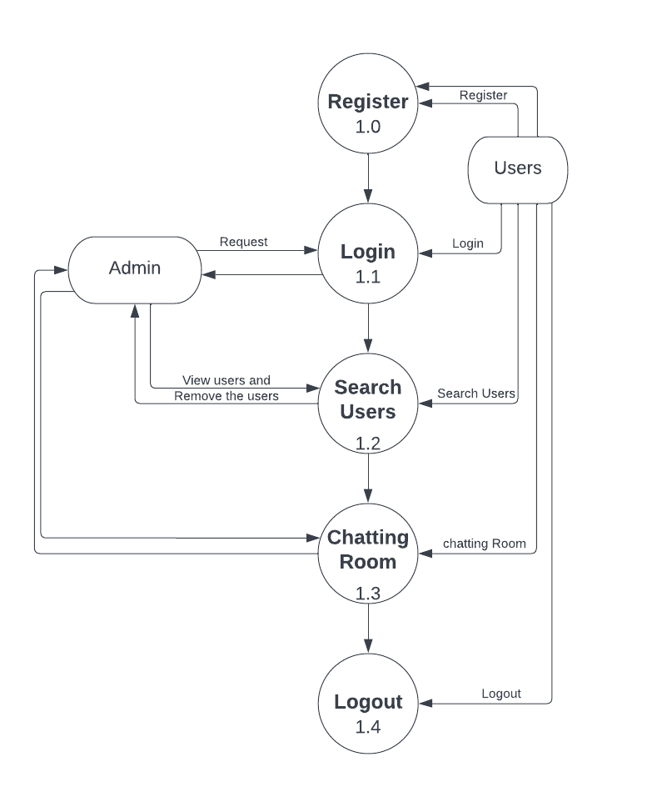

First Level DFD.

**Second Level:**

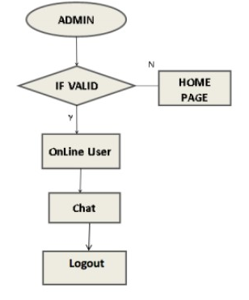

Second Level DFD.

**ER DIAGRAM(ENTITY RELATIONSHIP DIAGRAM):-**

The Entity-Relationship (ER) model was originally proposed by Peter in 1976 as a way to unify the network and relational database views. Simply stated the ER model is a conceptual data model that views the real world as entities and relationships. A basic component of the model is the Entity-Relationship diagram which is used to visually represent data objects.

Since Chen wrote his paper the model has been extended and today it is commonly used for database design for the database designer, the utility of the ER model.

It is simple and easy to understand with a minimum of training.

Therefore, the model can be used by the database designer to communication the design to the end user.

**ER DIAGRAM:-**

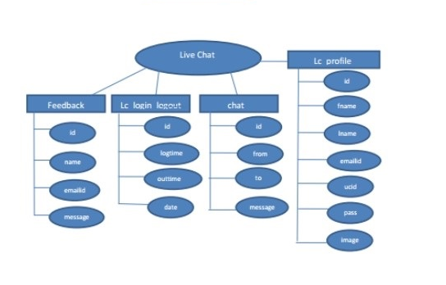

* **Forntend Technology:-**
* **HTML (Hypertext Markup Language).**
* **CSS (Cascading Style Sheets).**
* **BOOTSTRAP.**
* **JavaScript.**
* **AJAX (Asynchronous JavaScript and XML).**
* **Backend Technology:-**
  + **PHP (Hypertext Preprocessor).**
* **DataBase Handling Technology:-**
* **PhpMyAdmin.**

**Screen Shots:-**

* **Home Page:-**

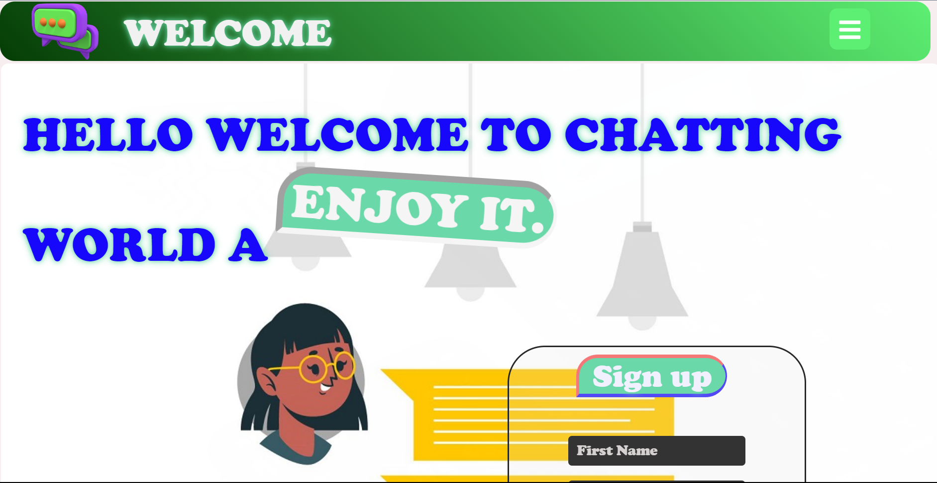

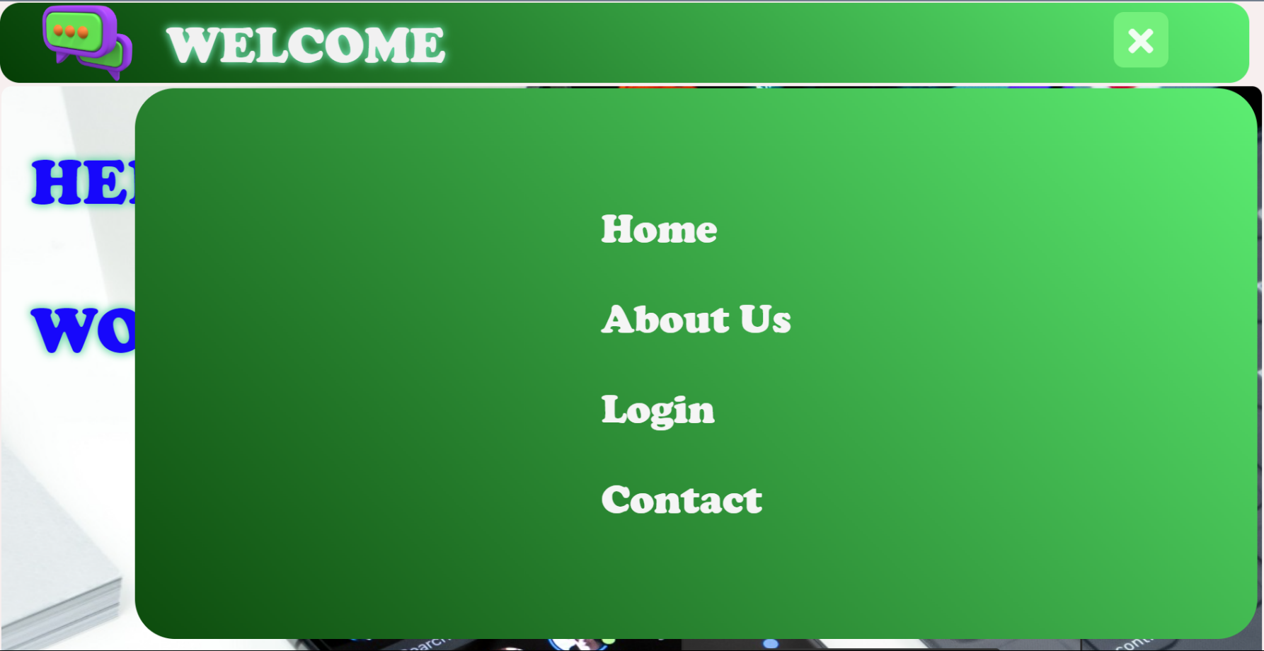

* **Sign up page:-**

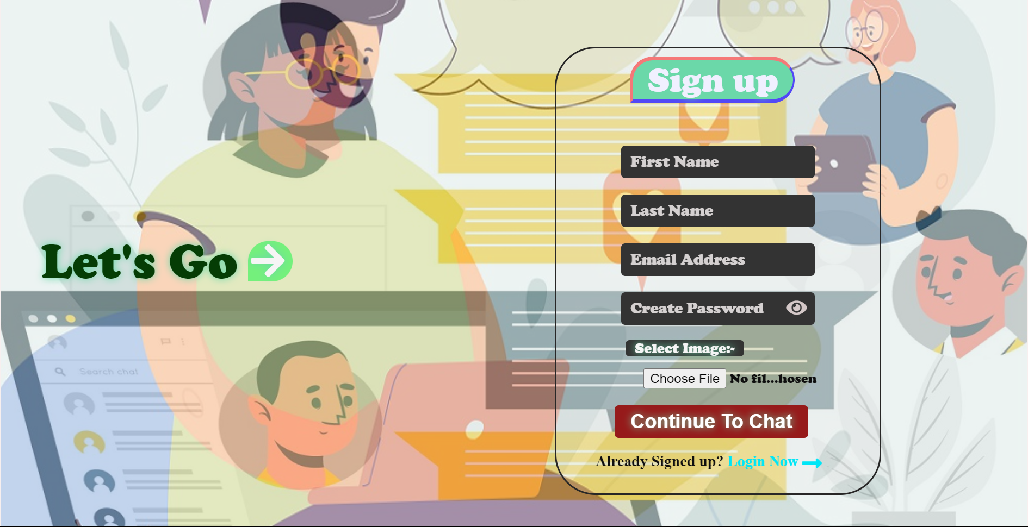

* **Footer page:-**

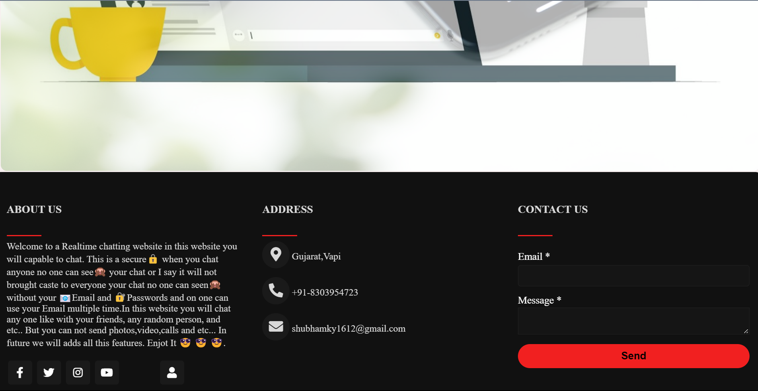

* **Login Page:-**

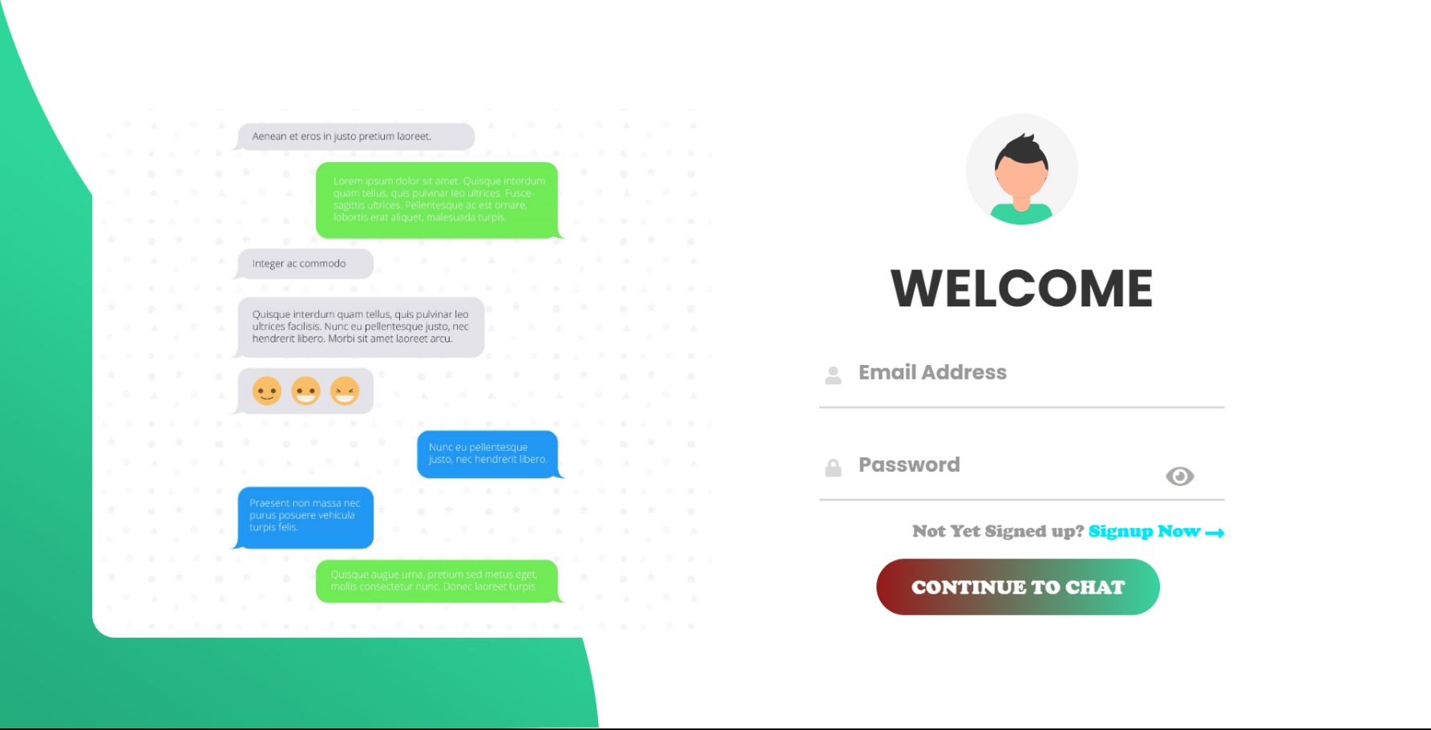

* **User Search Page:-**

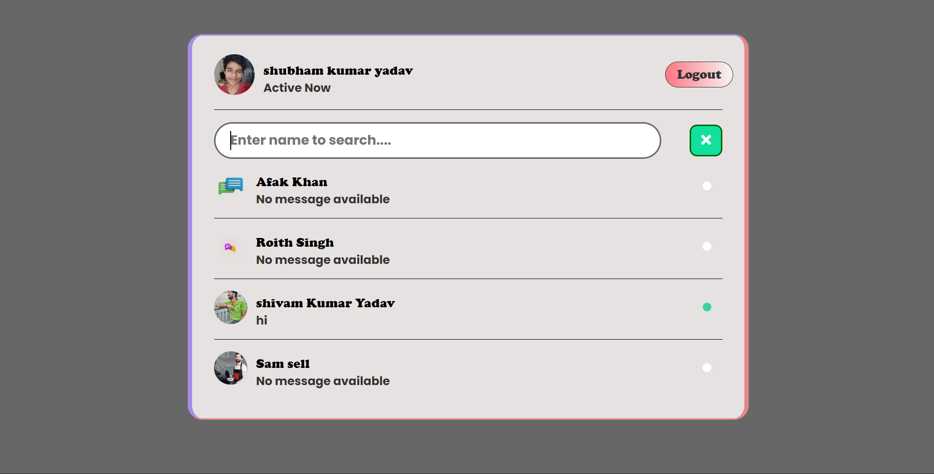

* **Chat Room Page:-**

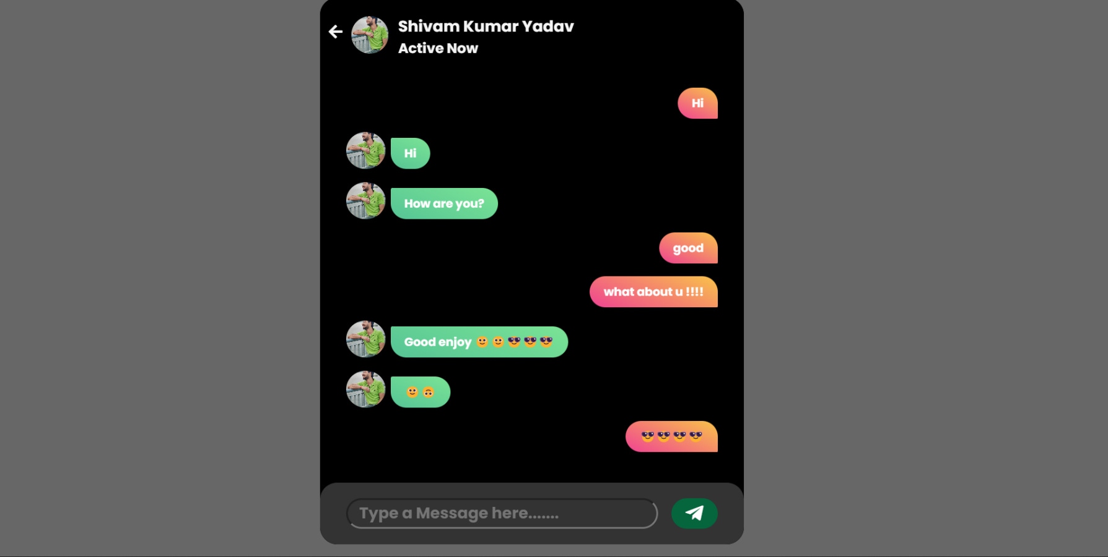

* **Admin Login Page:-**

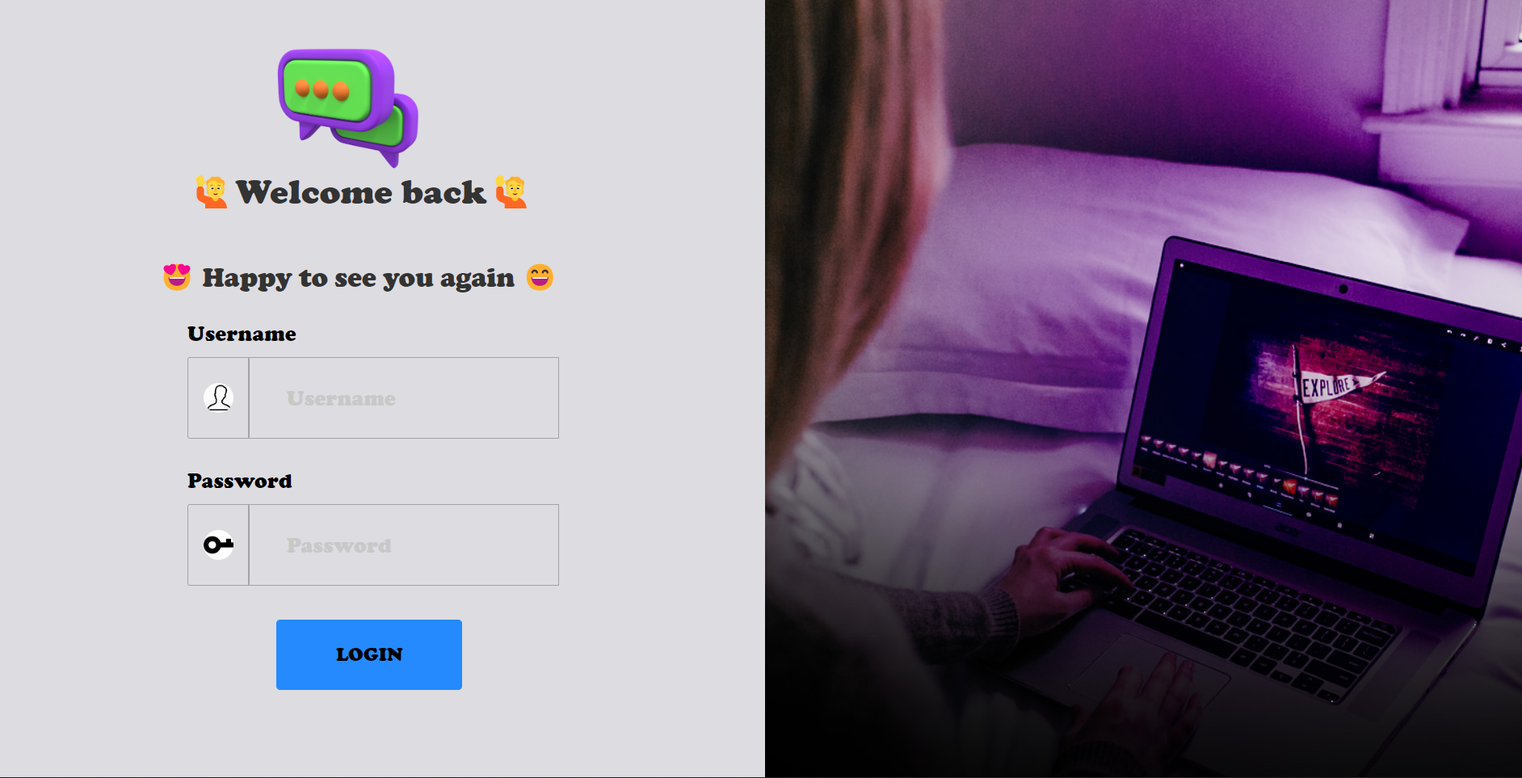

* **Admin Panal Page:-**

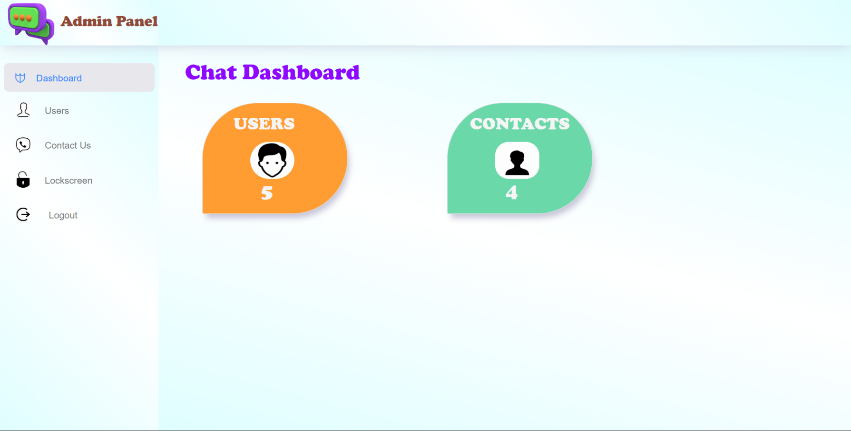

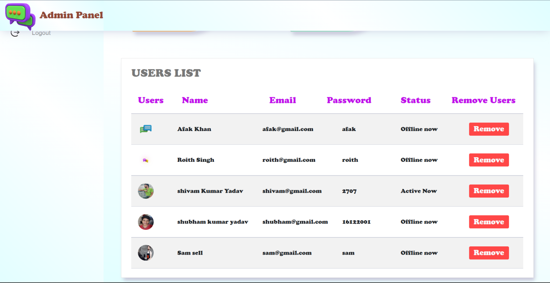

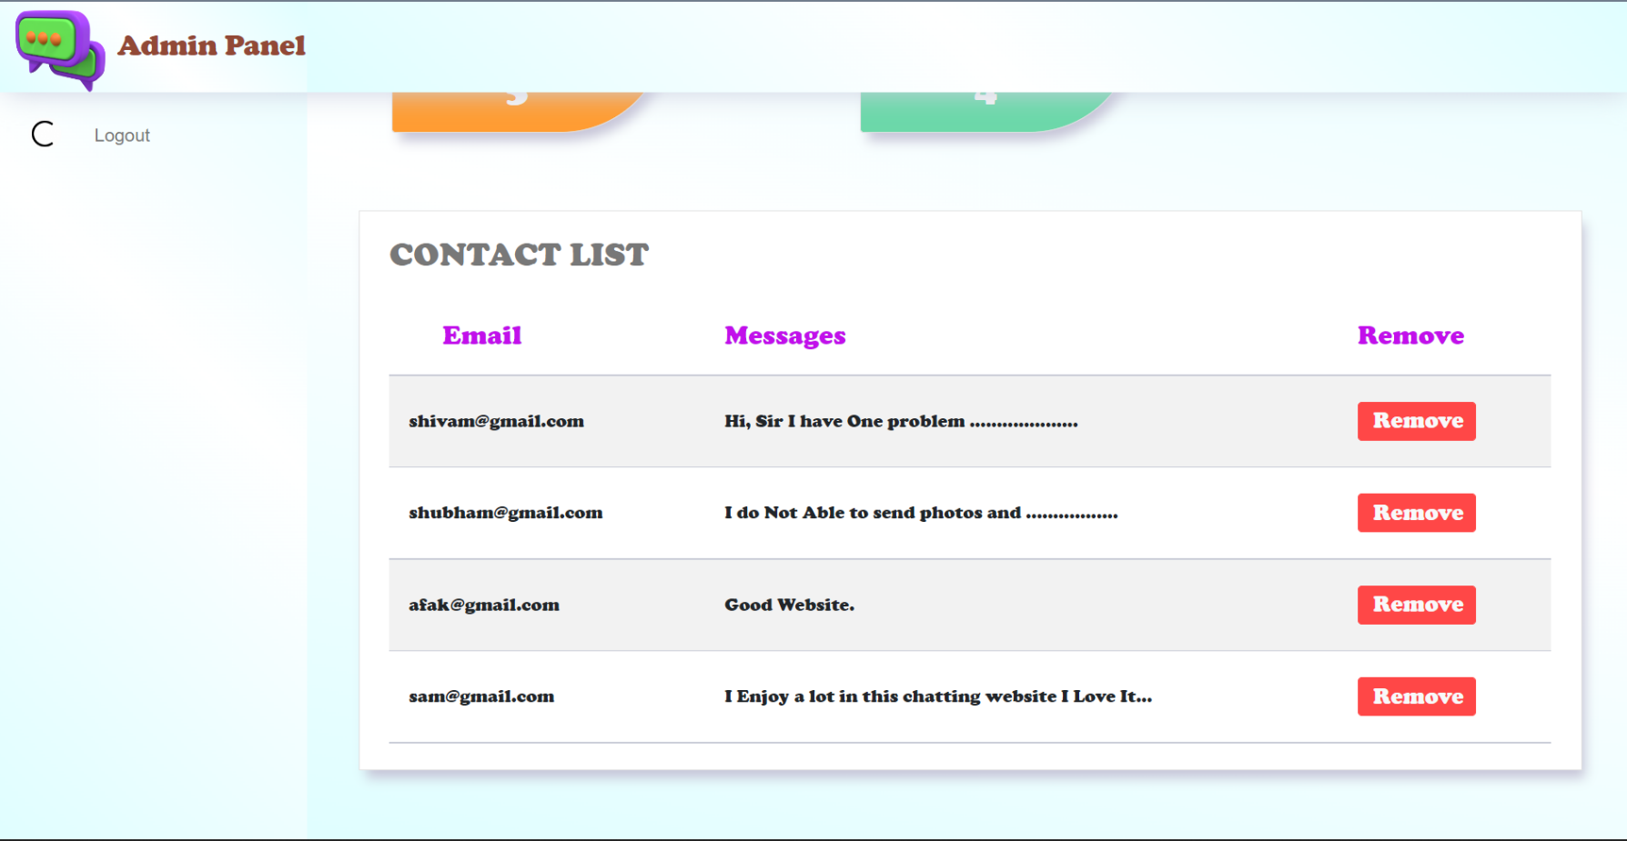

* **Lock Screen Page:-**

